- Git Setup https://confluence.atlassian.com/bitbucket/set-up-git-744723531.html
to install git
sudo apt-get install git
to add ssh key
ssh-keygen -t rsa
to configure account

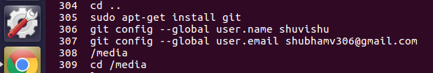

- Initialize a Git Repository
hackerfreak@hackerfreak:/media/hackerfreak/New Volume/UbuntuWorkSpace/Git$ git init newrepoVCS
Initialized empty Git repository in /media/hackerfreak/New Volume/UbuntuWorkSpace/Git/newrepoVCS/.git/
- Add files to the repository
hackerfreak@hackerfreak:/media/hackerfreak/New Volume/UbuntuWorkSpace/Git/newrepoVCS$ git add prog
adding multiple files
hackerfreak@hackerfreak:/media/hackerfreak/New Volume/UbuntuWorkSpace/Git/newrepoVCS$ git add newfile1 newfile2
- Unstage 1 file

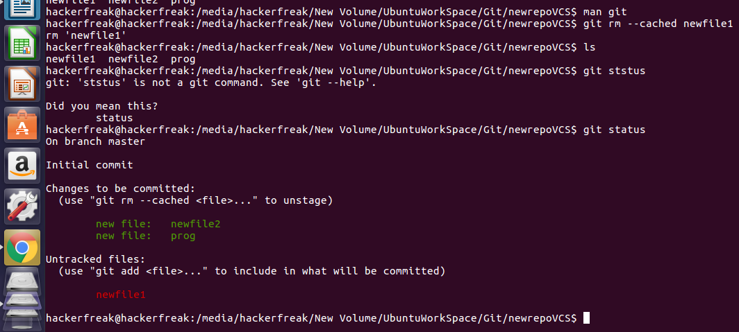

- Commit the file

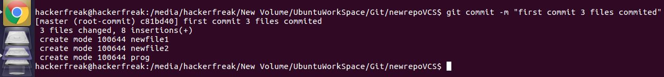

- Add a remote
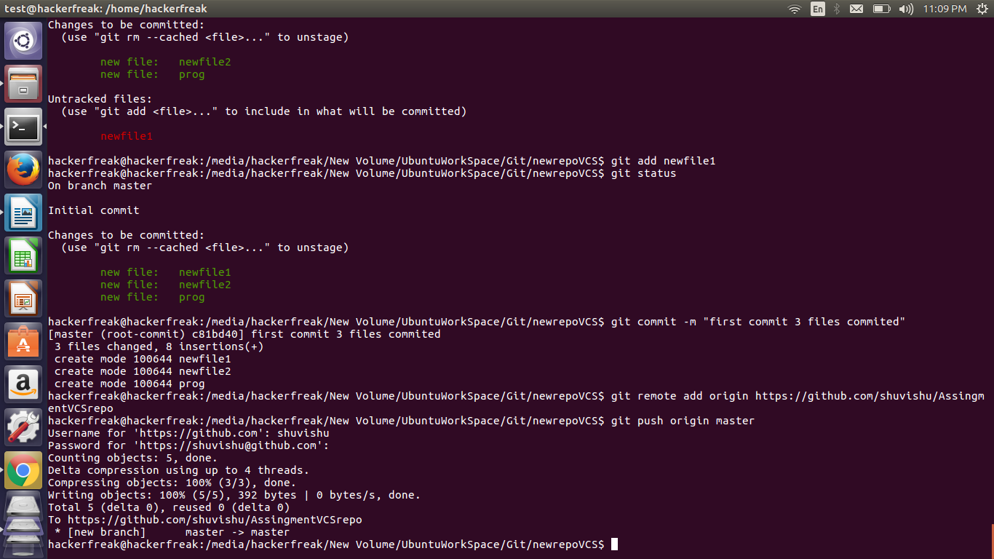
- Undo changes to a particular file
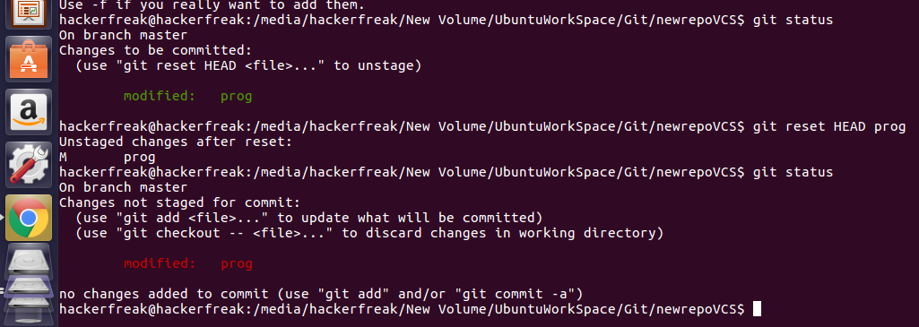

- Push changes to Github
- Clone the repository
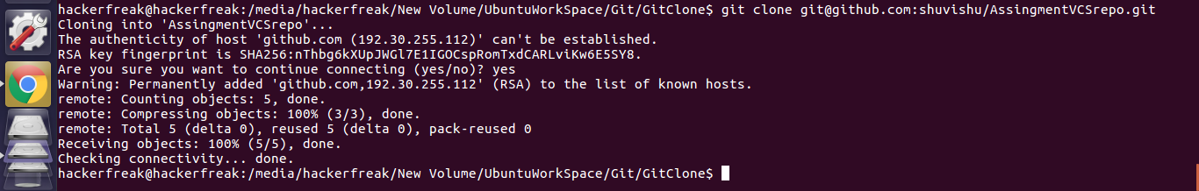
- Add changes to one of the copies and pull the changes in the other.
Changes made in cloned repository and file prog is displayed
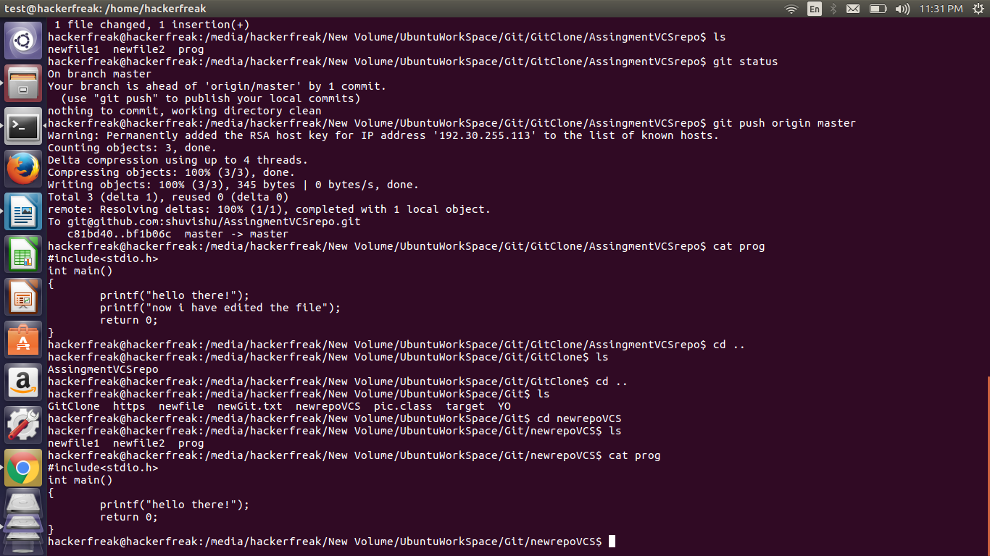
pulling the changed file

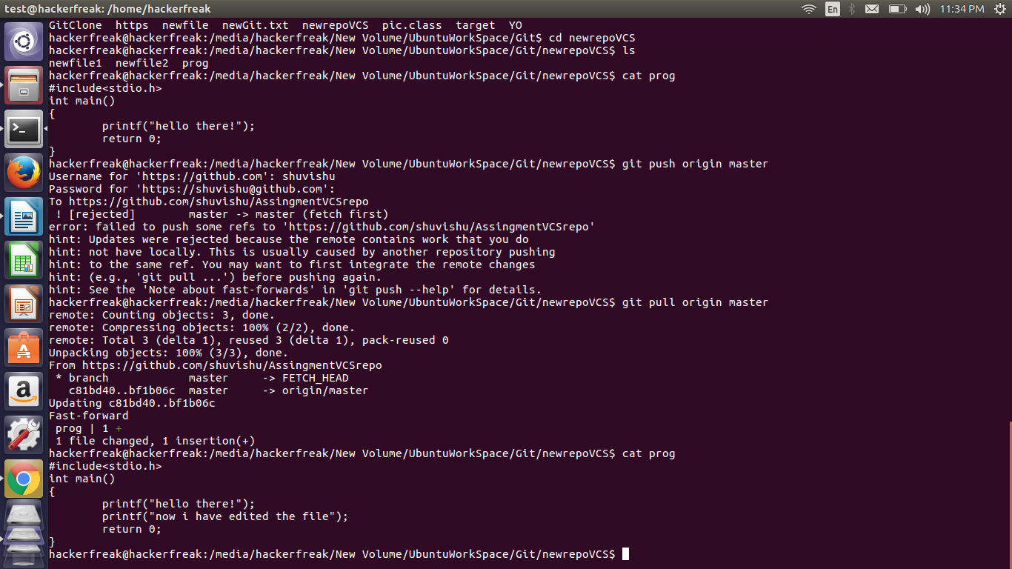
- Check differences between a file and its staged version
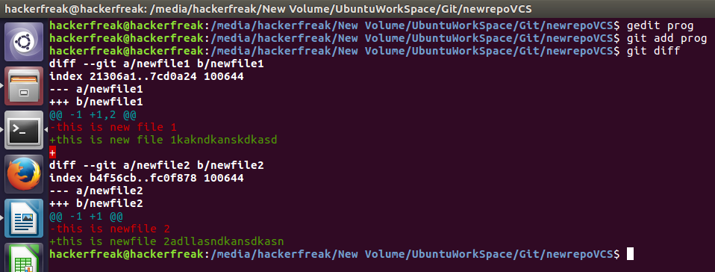

- Ignore a few files to be checked in
.gitignore contains *.class and *.bkp hence in git status no untracked file
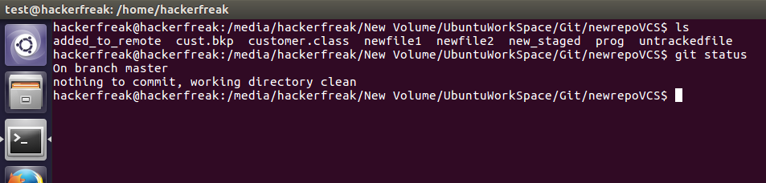
- Create a new branch.
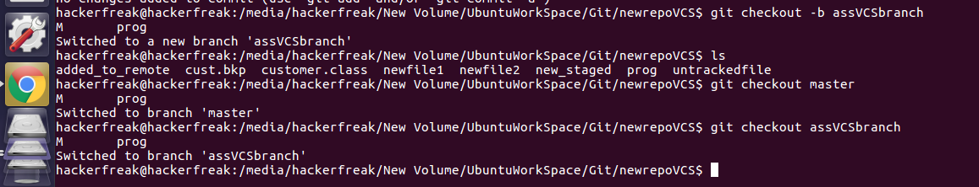

- Diverge them with commits
- Edit the same file at the same line on both branches and commit
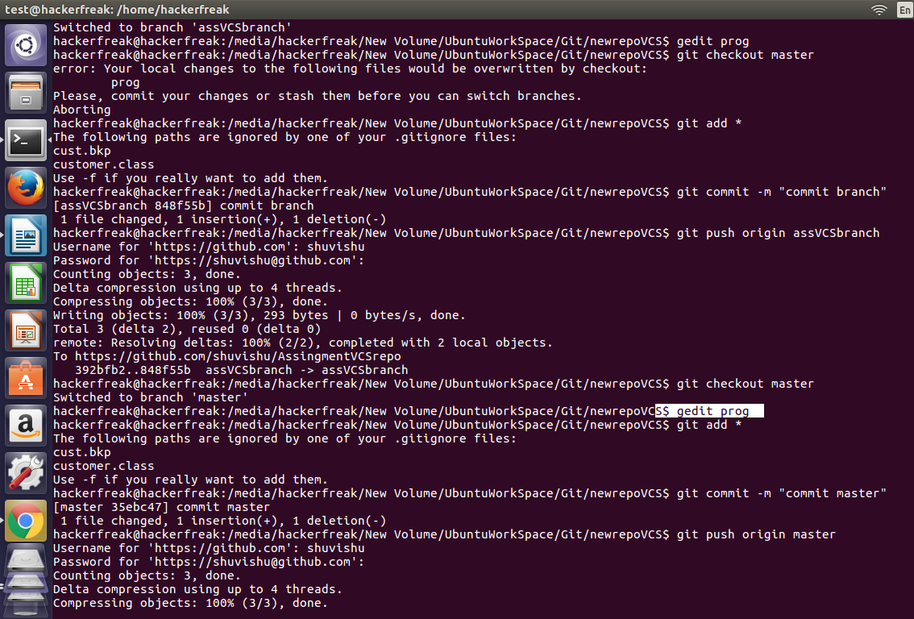
- Try merging and resolve merge conflicts
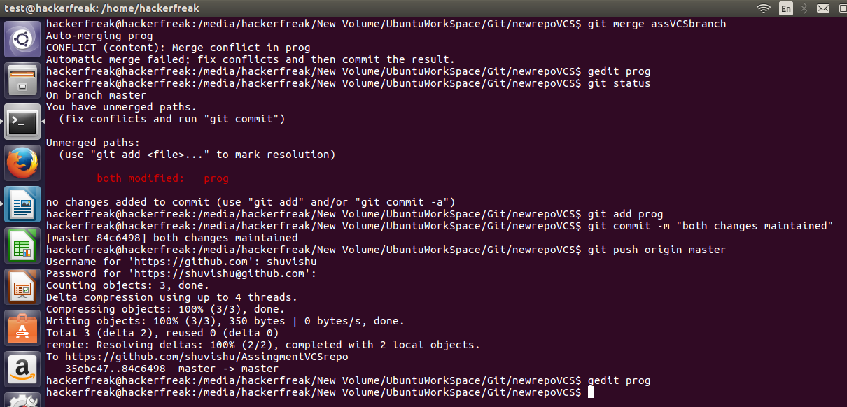

- Stash the changes and pop them

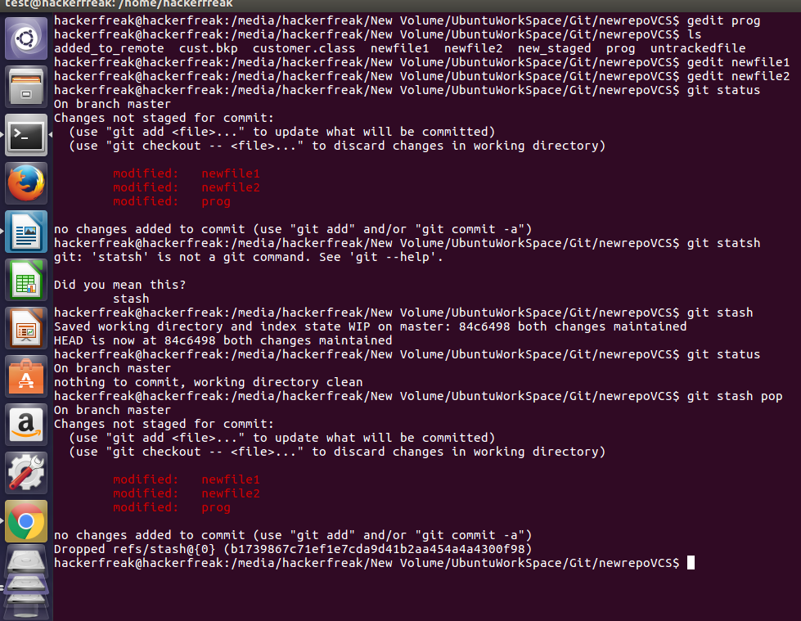

- Add the following code to your .bashrc file : color_prompt="yes"
parse_git_branch() {
git branch 2> /dev/null | sed -e '/^[^*]/d' -e 's/* \(.*\)/(\1)/'
}
if [ "$color_prompt" = yes ]; then
PS1='\u@\h\[\033[00m\]:\[\033[01;34m\]\W\[\033[01;31m\] $(parse_git_branch)\[\033[00m\]\$ '
else
PS1='\u@\h:\W $(parse_git_branch)\$ '
fi
unset color_prompt force_color_prompt

code added

